ABSTRACT: This is a sample file demonstrating the style for SHMII-13 full papers and extended abstracts. The length of the **full paper** is limited to **6 to 10 pages** and **2 to 6 pages for extended abstracts**. The paper should be written in English. It must consist of an abstract (max.1500 characters), a list of key words, an introduction, one or more main sections, a conclusion, and a list of references. Please carefully follow the guidelines given in this document. Papers not complying with the guidelines will not be included in the proceedings of SHMII-13.

Guidelines for SHMII-13 papers and extended abstracts

Author_11, ORCID (optional), Author_22, ORCID (optional), Author_31, ORCID (optional)

1Institute of Technology and Testing of Construction Material, Faculty of Civil Engineering Sciences, Graz University of Technology, Inffeldgasse 24, 8010 Graz, Austria

2Institute of Engineering Geodesy and Measurement Systems, Faculty of Mathematics, Physics and Geodesy, Graz University of Technology, Steyrergasse 30, 8010 Graz, Austria

email: author1@tugraz.at, author2@tugraz.at, author3@tugraz.at

KEY WORDS: SHMII-13; Full paper; Extended Abstract; Sample file.

# General guidelines

Your SHMII-13 paper should be formatted in the same way as this sample file. Please follow the same double column layout and do not change margins, font styles or sizes, or heading numbering schemes.

The paper must be written in English [1]. The length of a **full paper** has to be within **6 to 10 pages**. The length of **extended abstracts** has to be within **2 to 6 pages**. The paper must be submitted as a PDF document and also as a Word document. The file size should not exceed 10 MB for PDF and 30 MB for Word files. Headers and footers will be added to the paper by the editors, so please make sure the files are not protected in any way.

The paper must be uploaded on the SHMII-13 web site <https://www.conftool.com/shmii-13/>. The deadline for submission is 17 March 2025. Papers submitted later than this deadline may not be included in the proceedings of SHMII-13.

All submitted contributions will be peer-reviewed. All accepted full papers or extended abstracts of the conference will be published by the ‘Verlag der TU Graz’ (https://www.tugraz-verlag.at/en/) as open access E-book with a DOI number.

Please note that at least one of the authors must be registered as a participant at the conference and must give a presentation on the submitted contribution.

# Structure of the paper

## Title

The title (format style: ‘titel’) of the paper must be identical to the title of the abstract that has been submitted.

## Authors

A comma-delimited list of authors must be given, with full affiliations in the form Department, Company/Institution, Address, and a comma-delimited list of email addresses.

## Abstract

The abstract must give a summary of the paper. It must include the following elements:

* the motivation for the proposed research
* an outline of the methodology followed
* an overview of the results
* the conclusions.

The length of the abstract is limited to 15 lines. The abstract should be self-contained and it must not refer to the other parts of the paper (such as the list of references).

## Key words

Include a concise list of key words (not more than ten), for example: Bridge dynamics; Human induced vibrations; Inverse problems. Key words should be capitalized and separated by semicolons and the list should be terminated by a period.

## Main sections

The main part of the paper should start with an introduction and end with a conclusion. Section and subsection headings should be formatted and numbered as in this example file (using format styles). The sections *Acknowledgments* and *References* should not be numbered.

## References

A numbered list of references (format style: ‘references’) should be provided. Make sure that all references are complete: for journal papers, provide initials, name, journal, volume, number, page numbers, and year; for books, provide initials, name, title, edition, publisher, city, country, and year.

# Equations, figures, and tables

Equations should be centered and the numbering should be right-justified. Here is an example of an equation:

$\dot{x}=Ax+Bu$ (1)

Use standard symbols and nomenclature. Quantities should be expressed in SI units [2].

Figures and tables should be centered, numbered, and provided with a caption. Figure captions must be placed below the figure, while table captions must be placed above the table. All figures and tables must be explicitly referred to in the text of the paper using a link. Examples are shown in Figure 1 and Figure 2 and in Table 1. If you include photographs or other bitmaps, please make sure that the quality is sufficiently high for printing (at least 150 dpi).

figure1

Figure 1. First sample figure.

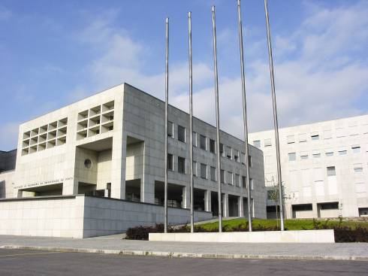

Figure 2. Second sample figure.

Table 1. Sample table.

|  |  |  |  |
| --- | --- | --- | --- |
| Mesh size | 60 × 20 | 150 × 50 | 300 × 100 |
| Method 1 | 0.65 | 75.19 | - |
| Method 2 | 0.15 | 0.72 | 1.85 |
| Method 3 | 0.13 | 0.69 | 1.98 |
| Method 4 | 0.13 | 0.78 | 2.18 |

# ACKNOWLEDGMENTS

This optional section contains acknowledgments.

# References

1. J. Simpson and E. Weiner, Eds., The Oxford English dictionary, Clarendon Press, Oxford, UK, second edition, 1989.
2. Bureau International des Poids et Mesures, The international system of units (SI), BIPM, Paris, France, eighth edition, 2006.