[Arial 15, bold] Copolymerization of diacrylates and diols via oxa-Michael and anionic polymerization

[Arial 12, underline the presenting author] Susanne M. Fischer,^{a,b} Christian Slugovc^{a,}*
[Arial 12, iltalics] ª Christian Doppler Laboratory for Organocatalysis in Polymerization, Graz University of Technology, Stremayrgasse 9, A 8010 Graz, Austria; e-mail: slugovc@tugraz.at
^{b} current address: Department of Organic and Macromolecular Chemistry, Polymer Chemistry Research Group, Ghent University, Krijgslaan 281 S4-bis, B 9000 Ghent
Belgium

[Times New Roman, 13] Oxa-Michael addition polymerization is a potential alternative to aza- or thia-Michael polymerization using generally less expensive, less toxic and bio-sourced alcohols.¹ However, alcohols are significantly less reactive compared to their amine and thiol counterparts and require the use of tailored catalysis to react with moderately strong Michael acceptors such as acrylates. Best catalysts for the oxa-Michael polymerization of acrylates are the strong Lewis bases such as tris(2,4,6-trimethoxyphenyl)phosphine (TTMPP), or strong Brønsted bases like P₂-^{t}Bu.² Moreover, the reactivity of acrylates in this reaction decreases with increasing functionality further complicating the formation of polymeric networks.
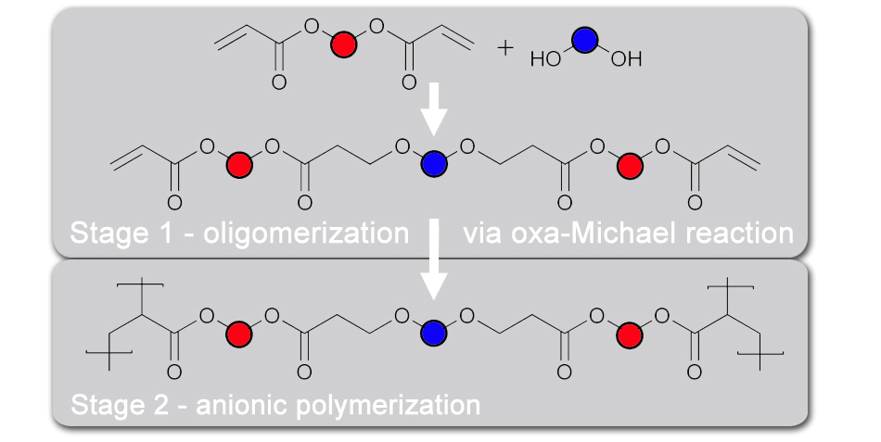
[Times new Roman, 12, italics] Two stage copolymerization of diacrylates and diols.

Herein, we present the synthesis of polymers via the combination of oxa-Michael reactions of diacrylates and diols in stoichiometric deficiency followed by subsequent anionic polymerization of the remaining acrylate groups. TTMPP and P₂-^{t}Bu have been found to be efficient catalysts for both reactions and enable the preparation of co-polymers with varying properties (e.g. thermal stability, hardness, etc.) depending on, above all, the alcohol content. When stronger difunctional Michael acceptors such as divinyl sulfone are used, less active catalysts are sufficient to obtain a similar reactivity.³

[Arial, 11; use ACS style without title –give only the first page number] References:
1 Ratzenböck, K.; Fischer, S. M.; Slugovc, C. Monatsh. Chem. 2023, 154, 443.
2 Fischer, S. M.; Kaschnitz, P.; Slugovc, C. Catal. Sci. Technol. 2022, 12, 6204.
3 Fischer, S. M.; Schallert, V.; Uher, J. M.; Slugovc, C. Polym. Chem. 2023, 14, 1081.

